## **WATCHKEEPER SECURITY MONITORING DASHBOARD**

### **1 TOTAL ACCOUNTADMIN USERS**

Select

Count(Distinct(GRANTEE_NAME)) as Total_Users

from

snowflake.account_usage.grants_to_users

where

role = 'ACCOUNTADMIN'

and deleted_on is null

and GRANTEE_NAME in (

Select

Distinct(Name)

from

snowflake.account_usage.users

where

deleted_on is null

);

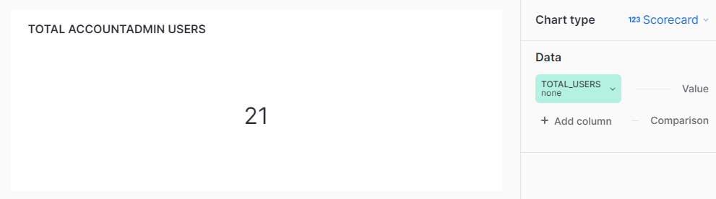

### 

### **2 USER TO ROLE RATIO (LARGER IS BETTER)**

select

round(

(

select

count(Distinct(Name))

from

"SNOWFLAKE"."ACCOUNT_USAGE".USERS

where

deleted_on is null

)

/(

select

count(distinct(name))

from

"SNOWFLAKE"."ACCOUNT_USAGE".roles

where

deleted_on is null

)

,

2) as user_to_role_ratio;

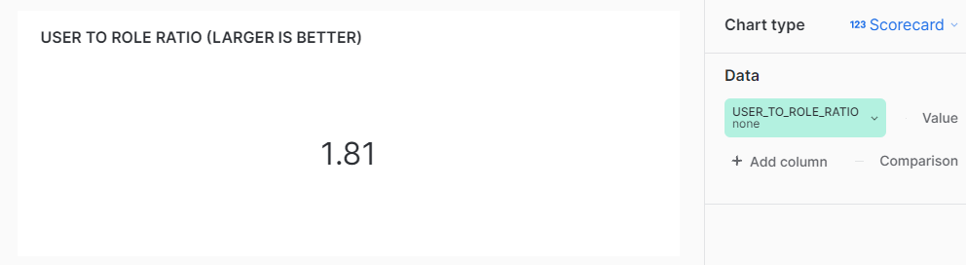

### 

### **3 TOTAL DISCONNECTED ROLES**

select

count(*) as Disconnected_role_count

from

MONITOR_DB.SECURITY_MONITOR_SCHEMA.ROLES_INFO_TB

where

ROLE_TYPE = 'Disconnected Role';

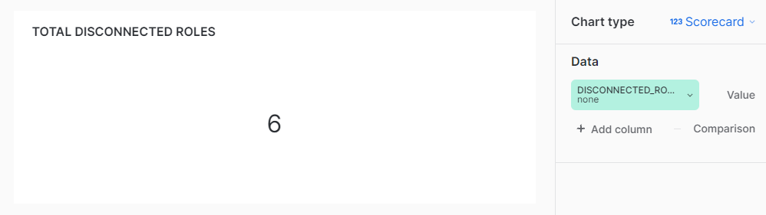

### **4 LOGIN ERROR %**

Select

round(

(

(

Select

count(*)

from

snowflake.account_usage.login_history

where

is_success = 'NO'

) /(

Select

count(*)

from

snowflake.account_usage.login_history

) * 100

),

2

) as Login_Error_Perct;

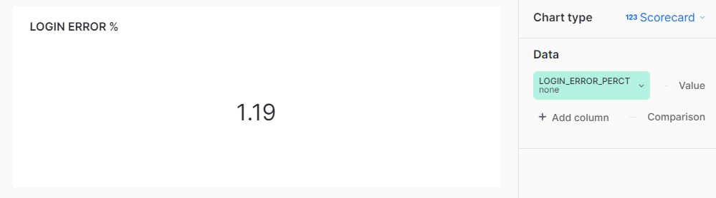

### **5 USERS HAVING MOST PRIVILEGES**

select

privilege,

gtu.grantee_name as USER_NAME,

Count(DISTINCT(gtr.name)) as Privilege_count

from

SNOWFLAKE.ACCOUNT_USAGE.GRANTS_TO_ROLES as gtr,

SNOWFLAKE.ACCOUNT_USAGE.GRANTS_TO_USERS as gtu

where

gtr.grantee_name = gtu.role

and gtu.deleted_on is null

and gtr.deleted_on is null

and USER_NAME in (

Select

Distinct(Name)

from

snowflake.account_usage.users

where

deleted_on is null

)

group by

gtu.grantee_name,

gtr.privilege;

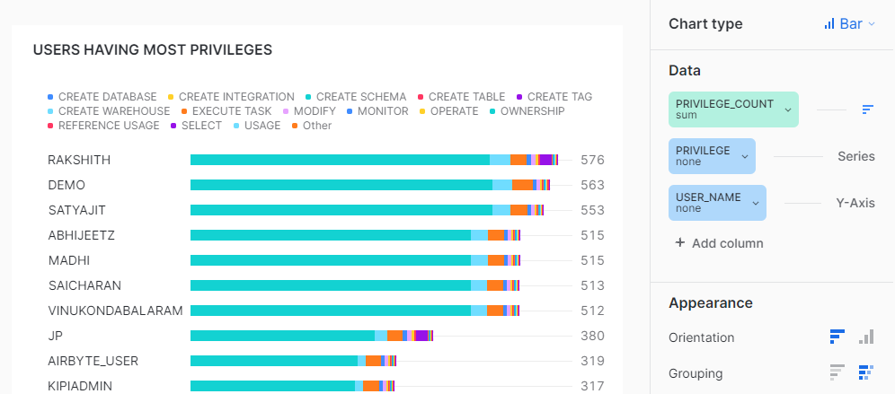

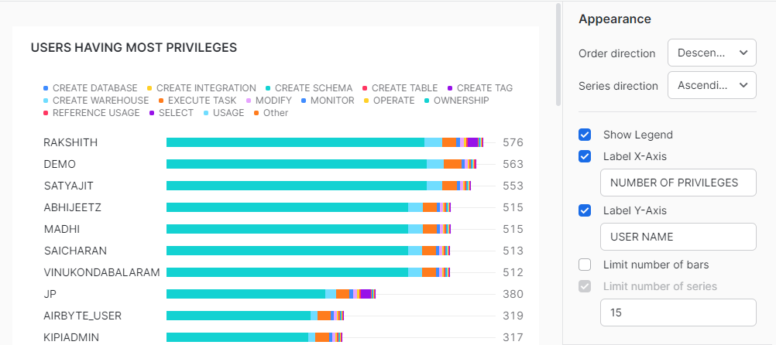

### **6 USERS NOT ENROLLED FOR MFA THROUGH DUO**

select

distinct(NAME) as User_Name

from

"SNOWFLAKE"."ACCOUNT_USAGE"."USERS"

where

deleted_on is null

and ext_authn_duo = 'false';

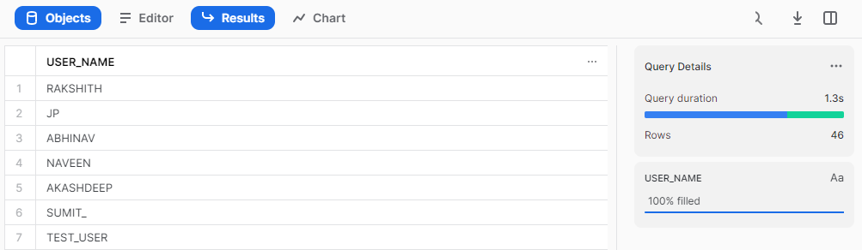

### **7 DISCONNECTED ROLE**

select

Name as Role_Name

from

MONITOR_DB.SECURITY_MONITOR_SCHEMA.ROLES_INFO_TB

WHERE

ROLE_TYPE = 'Disconnected Role';

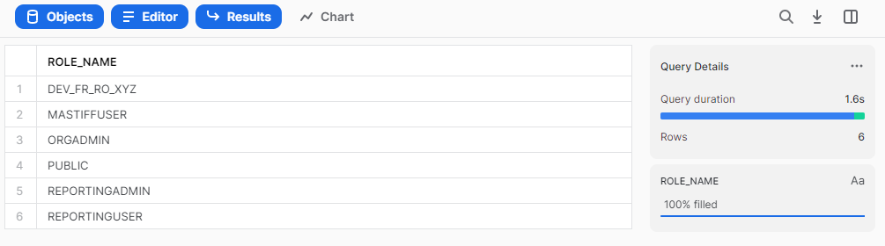

### **8 INACTIVE USERS BY QUERY EXECUTION**

select

count(query_id) Number_of_Queries,

user_name

from

"SNOWFLAKE"."ACCOUNT_USAGE"."QUERY_HISTORY"

where

USER_NAME in (

Select

Distinct(Name)

from

snowflake.account_usage.users

where

deleted_on is null

)

and start_time = :daterange

group by

user_name;

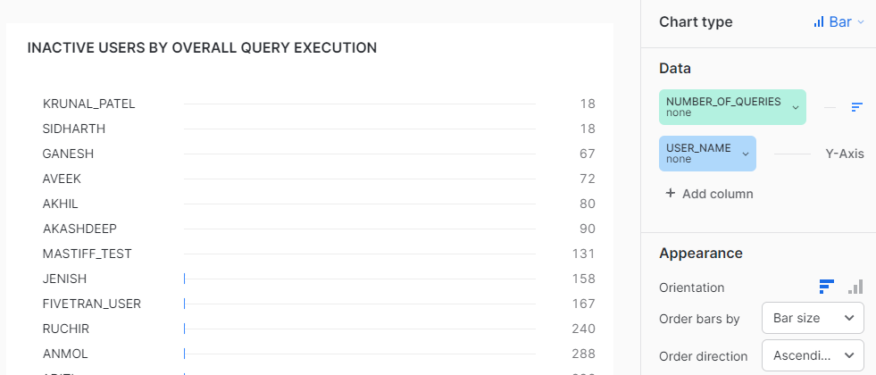

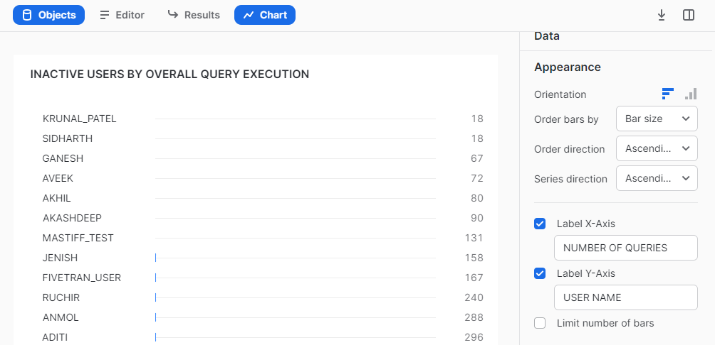

### **9 INACTIVE USERS BY LAST SUCCESS LOGIN**

select

NAME,

LAST_SUCCESS_LOGIN

from

"SNOWFLAKE"."ACCOUNT_USAGE"."USERS"

where

deleted_on is null minus

select

NAME,

LAST_SUCCESS_LOGIN

from

"SNOWFLAKE"."ACCOUNT_USAGE"."USERS"

where

LAST_SUCCESS_LOGIN = :daterange

and deleted_on is null;

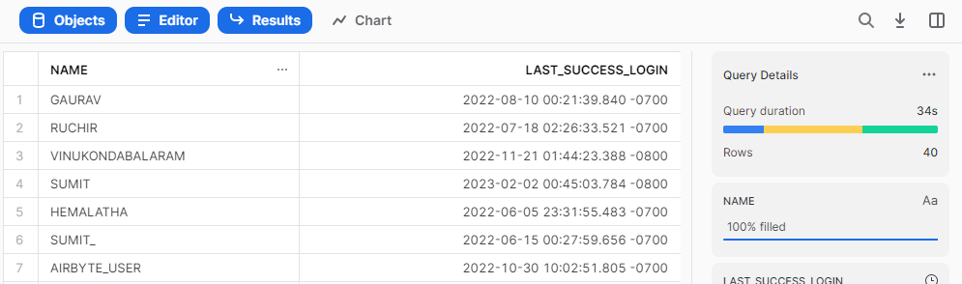

### **10 INACTIVE ROLE BY QUERY EXECUTION**

select

count(query_id) Number_of_Queries,

role_name

from

"SNOWFLAKE"."ACCOUNT_USAGE"."QUERY_HISTORY"

where

ROLE_NAME in (

Select

Distinct(Name)

from

snowflake.account_usage.roles

where

deleted_on is null

)

and start_time = :daterange

group by

role_name;

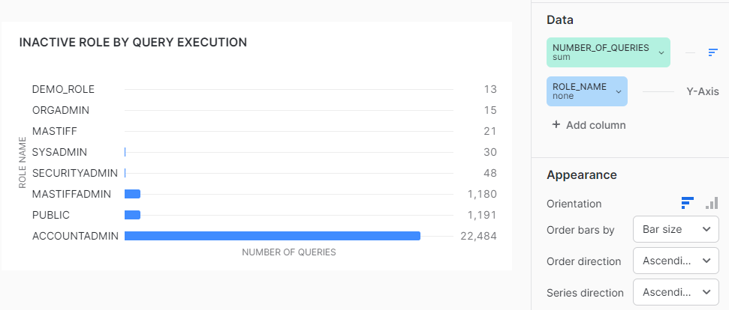

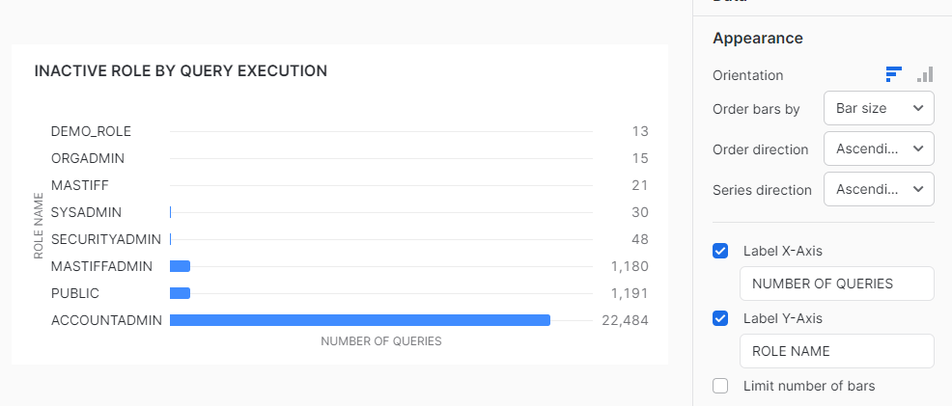

### **11 AUTHENTICATION BREAKDOWN**

select

AUTHENTICATION_FACTOR,

EVENT_COUNT

from

MONITOR_DB.SECURITY_MONITOR_SCHEMA.AUTHENTICATION_BREAKDOWN_TB;

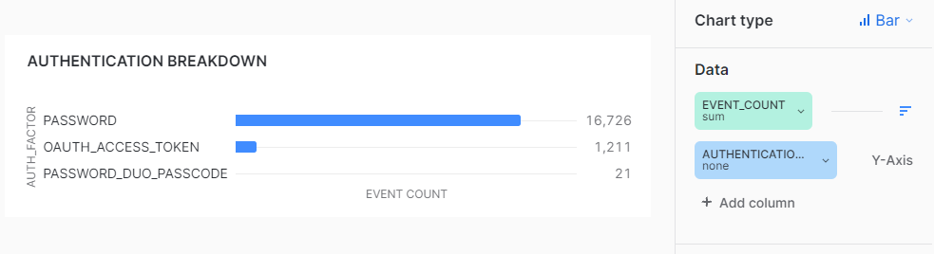

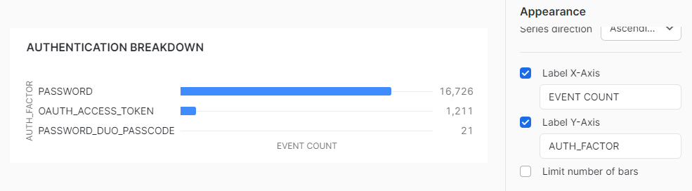

### **12 TOTAL SIGN-IN ERROR BY ERROR TYPE**

select

user_name,

event_timestamp,

error_message

from

"SNOWFLAKE"."ACCOUNT_USAGE"."LOGIN_HISTORY"

where

is_success = 'NO';

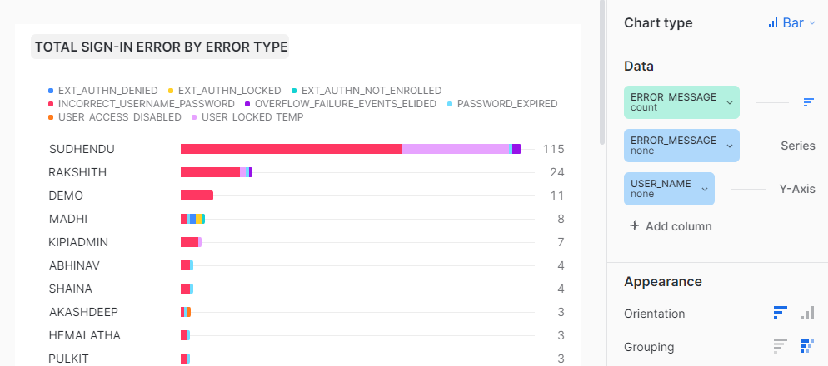

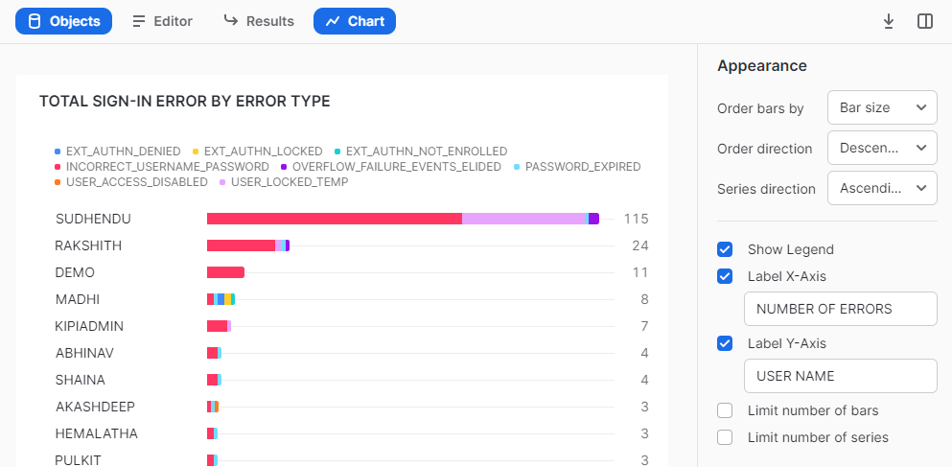

### **13 LEAST USED ROLE GRANTS FOR USERS**

select

User_name,

Role_name,

count(*)

from

"SNOWFLAKE"."ACCOUNT_USAGE"."QUERY_HISTORY"

where

USER_NAME in (

Select

Distinct(Name)

from

snowflake.account_usage.users

where

deleted_on is null

)

and role_name in (

Select

Distinct(Name)

from

snowflake.account_usage.roles

where

deleted_on is null

)

group by

user_name,

Role_name;

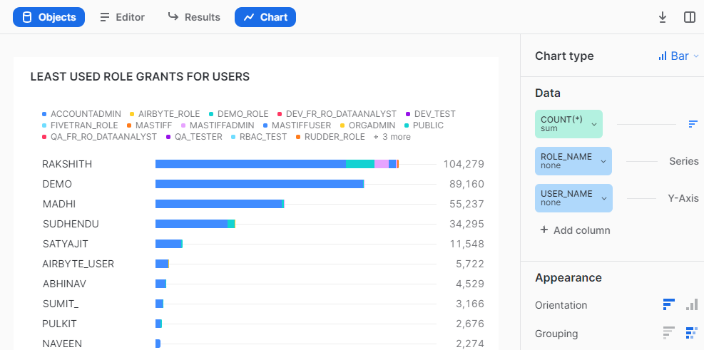

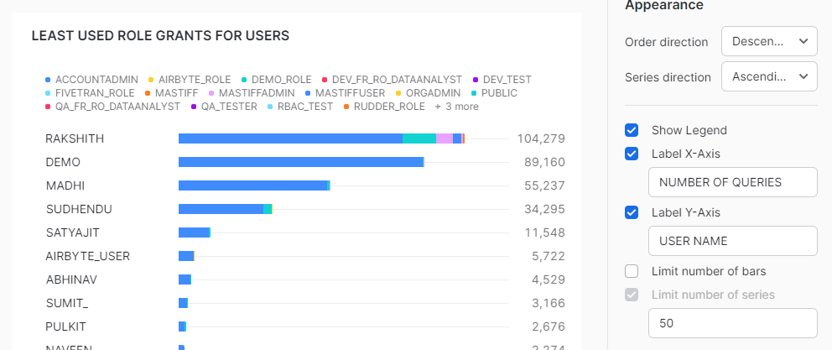

### **14 INDIVIDUAL USER TO ROLE RATIO**

select

1 / count(Distinct(role)) as User_to_Role_Ratio,

Grantee_name

from

"SNOWFLAKE"."ACCOUNT_USAGE"."GRANTS_TO_USERS"

group by

Grantee_name;

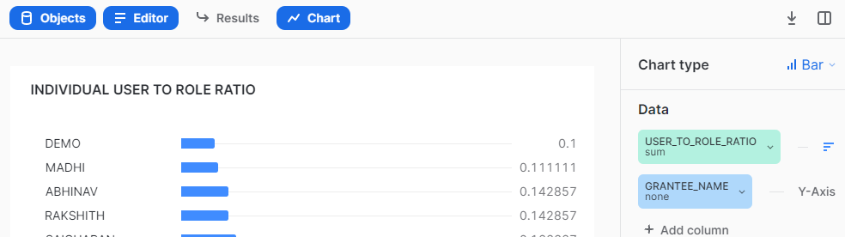

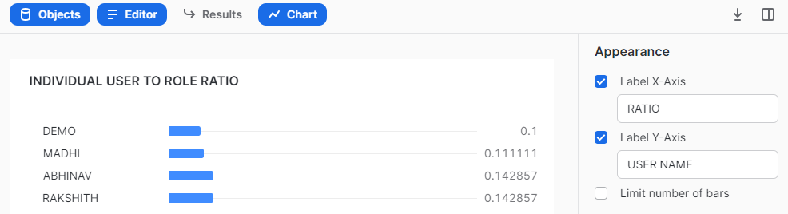

### **15 USER GRANTING ACCOUNTADMIN PRIVILEGES**

select

count(QUERIES),

USER_NAME,

ROLE_NAME

from

(

Select

UPPER(QUERY_TEXT) as QUERIES,

USER_NAME,

ROLE_NAME

from

SNOWFLAKE.ACCOUNT_USAGE.QUERY_HISTORY

where

query_type in ('GRANT')

)

where

QUERIES LIKE 'GRANT ROLE ACCOUNTADMIN%'

group by

USER_NAME,

ROLE_NAME

union

select

count(QUERIES),

USER_NAME,

ROLE_NAME

from

(

Select

UPPER(QUERY_TEXT) as QUERIES,

USER_NAME,

ROLE_NAME

from

SNOWFLAKE.ACCOUNT_USAGE.QUERY_HISTORY

where

query_type in ('GRANT')

)

where

QUERIES LIKE 'GRANT ROLE "ACCOUNTADMIN%'

group by

USER_NAME,

ROLE_NAME

union

select

count(QUERIES),

USER_NAME,

ROLE_NAME

from

(

Select

UPPER(QUERY_TEXT) as QUERIES,

USER_NAME,

ROLE_NAME

from

SNOWFLAKE.ACCOUNT_USAGE.QUERY_HISTORY

where

query_type in ('GRANT')

)

where

QUERIES LIKE 'GRANT ROLE IDENTIFIER%ACCOUNTADMIN%'

group by

USER_NAME,

ROLE_NAME;

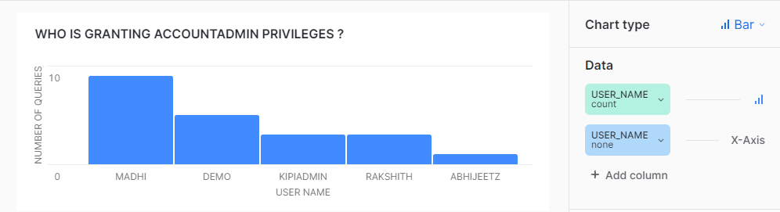

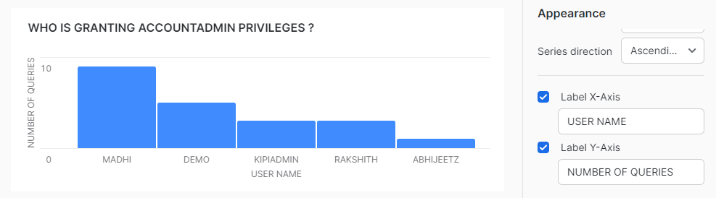

### **16 ACCOUNTADMIN PRIVILEGE GRANTED TO WHOM**

select

*

from

(

Select

upper(QUERY_TEXT) as QUERIES,

USER_NAME,

ROLE_NAME,

EXECUTION_STATUS

from

SNOWFLAKE.ACCOUNT_USAGE.QUERY_HISTORY

where

query_type in ('GRANT')

)

where

QUERIES LIKE 'GRANT ROLE ACCOUNTADMIN%'

union

select

*

from

(

Select

upper(QUERY_TEXT) as QUERIES,

USER_NAME,

ROLE_NAME,

EXECUTION_STATUS

from

SNOWFLAKE.ACCOUNT_USAGE.QUERY_HISTORY

where

query_type in ('GRANT')

)

where

QUERIES LIKE 'GRANT ROLE "ACCOUNTADMIN%'

union

select

*

from

(

Select

upper(QUERY_TEXT) as QUERIES,

USER_NAME,

ROLE_NAME,

EXECUTION_STATUS

from

SNOWFLAKE.ACCOUNT_USAGE.QUERY_HISTORY

where

query_type in ('GRANT')

)

where

QUERIES LIKE 'GRANT ROLE IDENTIFIER%ACCOUNTADMIN%';

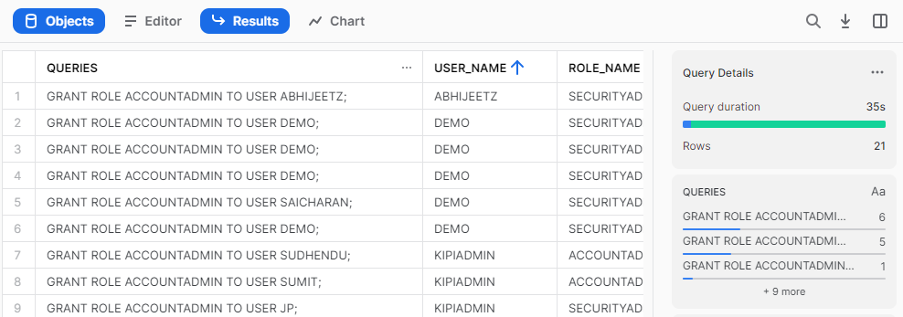

### **17 GHOST USERS (USERS WITHOUT ROLES)**

select

name as USER_NAME

from

SNOWFLAKE.ACCOUNT_USAGE.USERS

where

deleted_on is null

and USER_NAME not in (

select

distinct(grantee_name)

from

SNOWFLAKE.ACCOUNT_USAGE.grants_to_users

where

deleted_on is null

)

and name <> 'SNOWFLAKE';

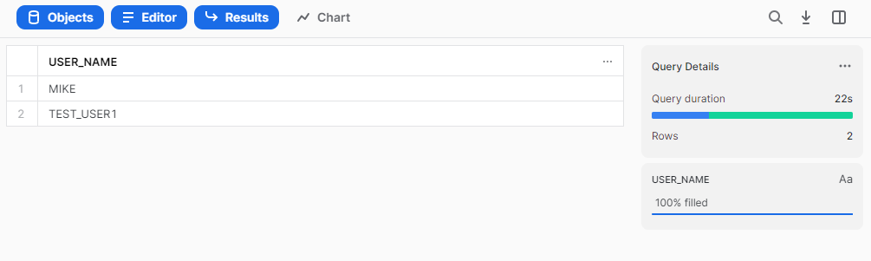

### **18 GHOST ROLES (ROLES WITHOUT PRIVILEGES)**

Select

name as Role_Name

from

SNOWFLAKE.ACCOUNT_USAGE.ROLES

where

Role_Name not in (

Select

distinct(grantee_name)

from

SNOWFLAKE.ACCOUNT_USAGE.GRANTS_TO_ROLES

where deleted_on is null

)

and Role_name in (

Select

Distinct(Name)

from

snowflake.account_usage.roles

where

deleted_on is null

);

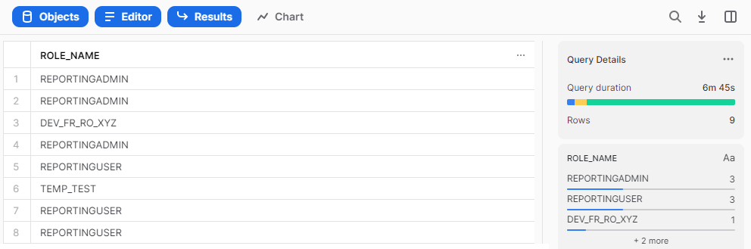

### **19 TOTAL POLICIES WITH BLOCKED & ALLOWED IPs**

select

*

from

MONITOR_DB.SECURITY_MONITOR_SCHEMA.NETWORK_POLICIES_TB;

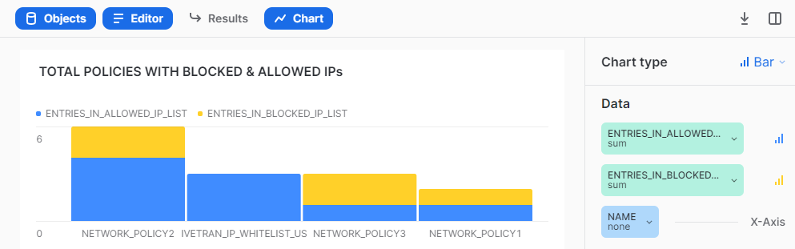

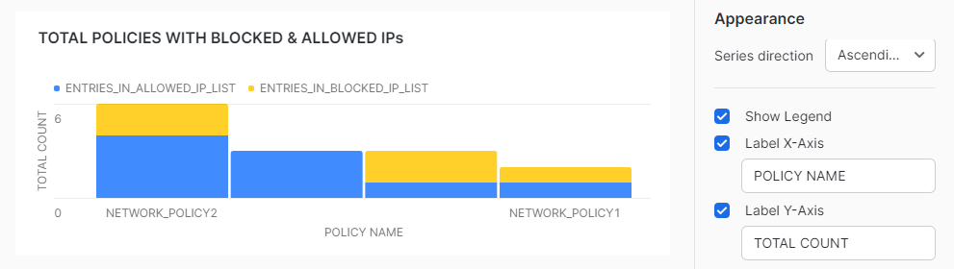

### **20 USER ALTERING NETWORK POLICIES**

select

*

from

(

Select

upper(QUERY_TEXT) as QUERIES,

USER_NAME,

ROLE_NAME,

START_TIME

from

SNOWFLAKE.ACCOUNT_USAGE.QUERY_HISTORY

where

query_type in ('ALTER_NETWORK_POLICY')

and execution_status = 'SUCCESS'

and USER_NAME in (

Select

Distinct(Name)

from

snowflake.account_usage.users

where

deleted_on is null

)

);

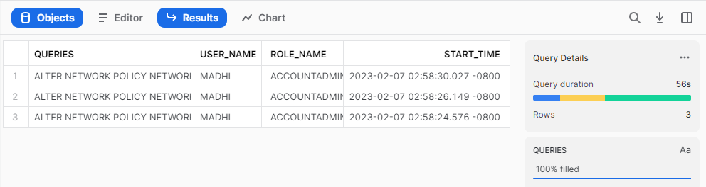

## **Best Practices -**

* If you have records more than 10000 then select only top 9999 ( refer. link:- <https://docs.snowflake.com/en/sql-reference/constructs/top_n.html>) to create a chart as Snowsight only supports data to be visualized till 9999 rows.
* It's preferable to do aggregation in the query itself rather than to do it in Snowsight UI.
* Adjust the round off value as per your requirement ( e.g - round((<column_name>), n) where n = natural number ).
* On hovering over any filter, visuals getting filtered would be highlighted.
* To make filter interaction more user friendly, you can even use color coding.
* All the KPIs for security monitor currently include disabled users. To exclude disabled users from the KPI calculations, simply add "disabled is null" in the WHERE conditions.